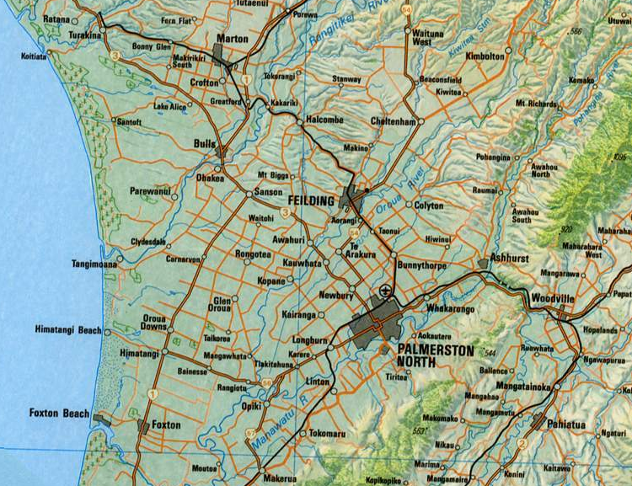

Feilding | 16
Foxton | 29 | …..
Foxton Beach | 33 | ….. | 6
Bulls | ….. | 20 | ….. | 34
Colyton | 15 | 6 | ….. | ….. | …..
Glen Orua | ….. | ….. | ….. | 20 | 16 | …..
 | Palmerston North | Feilding | Foxton | Foxton Beach | Bulls | Colyton

- Draw a network showing this information
- Can the network be traversed from Palmerston North back to Palmerston North?
- Can the network be traversed from any start/finish points?
- Can the network be traversed from Foxton, back to Foxton if doubling back is allowed? What is the shortest way in which this can be done?
- Draw a minimum spanning tree for this information.
- Draw a maximum spanning tree for this information.
- What is the shortest distance from Foxton to Bulls? Use an algorithm to do this calculation.

